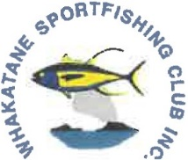
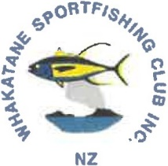
NZ
Annual Trout Tournament 2023 ENTRY FORM

Entry Fee: Junior $15 Full Member $25 Social/Non-member
Senior $30 Full Member $50 Social/Non-member
Briefing: Thursday 11th of May 2023-19:00
ALL SKIPPERS OR A NOMINATED “FISHING" TEAM MEMBER MUST ATTEND THE BRIEFING
Fishing: From 05:00 Saturday 13th May until 13:30 Sunday 14th of May

SKIPPERS NAME: |  |  | CONTACT PHONE #
BOAT NAME: |  |  | EMAIL:
 | ANGLERS FULL NAME |  | M LJ | M/SHIP NUMBER | License  Number | TOTAL
1
2
3
4
5
6
7
8
 |  |  |  |  | TOTAL FEES PAID
Internet Banking: 02 0488 0034035 26. Email to: office@wsfc.co.nz

Tournament rules understood. Skipper to sign…………………………………….

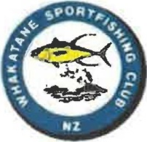

Annual Trout Tournament 2023 Rules

Rules

1. DATE

Saturday 13th May 2023
Sunday 14th May 2023

2. START TIME

All boats entered in this tournament CANNOT START FISHING until 05:00 on Saturday the 13TH of May 2023. Fishing concludes at 13:30 on Sunday the 14th of May 2023. THE FISHING AREA IS LAKE ROTOITI ONLY.

3. REGISTRATION

A minimum of 2 anglers per team. All anglers must be full members or (have paid the appropriate social/non-member membership fee) of the Whakatane Sportfishing Club.
Registrations will be taken up until 18:30 Thursday 11th of May 2023.

4. BRIEFING

The briefing will be held in the clubrooms at 19:00 Thursday 11th May 2023.
The Skipper or a nominated "fishing" team member must attend the briefing and at the completion of the briefing sign the briefing attendance sheet.

5. ENTRY FEES

Juniors - $15 Full Member - $25 Social/Non-Member
Seniors - $30 Full Member - $50 Social/Non-Member

6. SPECIES Rainbow & Brown Trout.

7. MINIMUIM SIZE

As per the fishing license requirements.

8. WEIGHING OF FISH

Weighing of fish will take place at Gisborne Point or Hinehopu Boat Ramp. Saturday the 13th May 2023 13:00 – 17:00, Sunday 14th May 2023 14:00 – 16:00.

9. CLASSES

Juniors – Heaviest, 2nd heaviest, 3rd heaviest, average weight.
Ladies - Heaviest, 2nd heaviest, 3rd heaviest, average weight.
Men - Heaviest, 2nd heaviest, 3rd heaviest, average weight.
All – Heaviest Trout caught Jigging
Mystery Weight
Heaviest trout caught shore/fly fishing
Hard Luck Draw (No Trout Caught)
Best condition factor (CF) = Weight (grams) divided by Length (CM’s). 1st, 2nd & 3rd.

10. PRIZE-GIVING

Prize-giving will be held in the Clubrooms from 19:00 on Sunday 14th May 2023.
To collect prizes the angler OR team member must be present at the prize-giving. For lucky angler or spot prizes the angler must be present.

11. DISPUTES

Any complaints regarding this tournament will be in the first instance directed to the Tournament Convener. The Tournament Committee will then consider the dispute. Any complaint must be submitted in writing. The decision of the Tournament Committee is final and binding. Angler entry constitutes agreement to this process. Any concern relating to the weighing of fish must be brought to the attention of the weigh master BEFORE the angler leaves the weigh station.

12. CANCELLATION OR POSTPONEMENT

The Tournament Committee reserves the right to abandon or postpone the Tournament for any reason. This information will be broadcast on Radios lXX and SunFM prior to start time or as soon as possible after a decision has been made. Notification will also be made on the club’s social media.

13. DISCLAIMER

All participants involved with this tournament do so at their own risk. The team skipper shall be responsible for the safety and other considerations of self, crew & boat. The Whakatane Sportfishing Club (Inc) accepts no responsibility.

